Ifedayo Adomayi
Art 2021
Melissa Borman
01st July,2017
Rough draft of the critical analysis- Keokuk Sauk chief
This picture was made by Thomas Easterly. It was one of his earliest inventions during the daguerreotype era. sometime calligrapher and writing teacher, Vermont-born Thomas Easterly was born in Vermont and lived between 1809-1882. He was once a calligrapher and teacher but had a strong interest in portraiture making. Hence he moved to New York to follow his passion. He decided to learned the daguerreotype process which was the main process of portraiture making at that time between 1841 and 1844, possibly from Charles and Richard Meade (Getty museum). This was the beginning of his career.
The subject of this image is the Keokuk Sauk Chief. One could see through the attire, that he is a man of authority. Keokuk, meaning Watchful fox, lived between 1767–1848. He was a “chief of the Sauk tribe in central North America noted for his cooperation with the U.S. government which led to war with Black Hawk, who led part of their band into the Black Hawk War” (Wikipedia). He fought for his tribe and tried to maintain peace as much as he could.
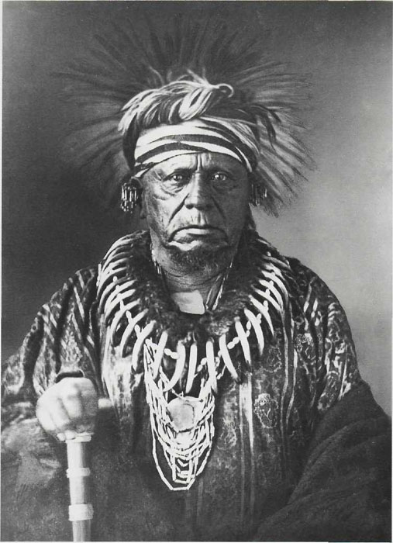
Fig. 1; Thomas Easterly. Keouk, Sauk Chief, 1847.
This portrait was made using the daguerreotype process. It is shown in the amount of lightning and how fine and detailed the portrait looks. To make a portrait using daguerreotype process, “the operator must first obtain the sensitized plate from the dark room, removed the focusing glass of the camera, insert the plate into the frame before beginning the exposure (Rosenblum 43). This process takes a lot of time and can be easily boring. This is seen in the serious expression of the sitter. During those times to take a portrait, one must be in “proper deportment and correct attire” (Rosenblum 52). Keouk attire is used during ceremonial celebration by the Sauk tribe. His appearance in this portrait emphasizes his authority and boldness in a fine and detailed manner.
The contrast in this portrait to life. One distinct element that stood out is the sitter’s face. This contrast enhanced it more, giving it the boldness and look of a warrior. This also blended with his expression. Although, it might partly be due to the lengthy daguerreotype process. The bear claws necklace also stood out especially with the focus of lightning on the claws itself. This is meant to show the braveness and courage of a warrior (Keouk chief). This head tie was also brought to life especially the feathers. It almost seemed real.
It is obvious that Thomas Easterly tried his best to capture the true essence of Keouk Sauk chief but there were various limitations ranging from the length process to the lack of color. Regardless of these limitations, Thomas could capture “the conjunction of appearance with moral character” (Rosenblum 49). This is a proof to Lavater’s ideas of physiognomy which is still seen in our everyday photo.
Works cited
Rosenblum, Naomi. A World History of Photography. New York, N.Y: Abbeville Press, 1984. Print
http://www.getty.edu/art/collection/artists/1806/thomas-martin-easterly-american-1809-1882/
https://en.wikipedia.org/wiki/Keokuk_(Sauk_leader)

